Practical 28 :

Code :

import java.applet.\*;

import java.awt.Graphics;

public class Hello extends Applet{

public void paint(Graphics g){

g.drawString("Welcome to the World of Applet",150,150);

}

}

Output :

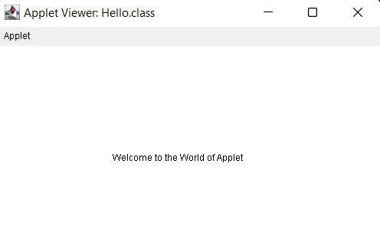

Code :

import java.applet.\*;

import java.awt.\*;

public class Meth extends Applet{

    String str;

    public void init()

    {

      str=getParameter("pname");

      if (str == null)

      str = "Welcome to the World of Applet";

      str = "Hello " + str;

    }

      public void paint(Graphics g)

      {

        g.drawString(str, 200, 200);

      }

}

Output :

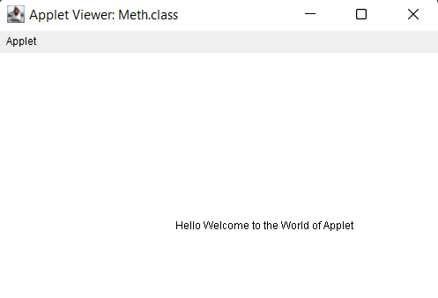

Code :

import java.awt.\*;

import java.applet.\*;

public class control extends Applet

{

 public void paint(Graphics g)

 {

   for(int i=0; i<=4; i++)

 {

  if((i%2)==0)

   g.drawOval(200, i\*(60+10), 50, 50);

  else

   g.fillOval(200, i\*(60+10), 50, 50);

  }

 }

}

Output :

